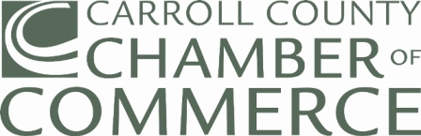 |  |  |  | 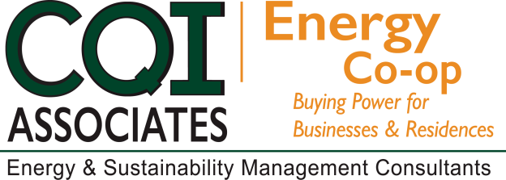
2018 SPRING CAMPAIGN
Dear Chamber Member:

The Chamber of Commerce has partnered with energy experts, CQI Associates, to offer you the services of the Chamber Energy Purchasing Cooperative Program. As part of an ongoing effort to provide value to our members, we are happy to announce the Spring 2018 enrollment campaign is underway.

BENEFITS  Increased Purchasing Power in procuring competitive electric and natural gas rates.  Budget Stability by offering Fixed Rate energy supply costs.  Year-round Customer Support through CQI Associates.  NO FEE to join the Co-op and one application covers ALL of your electricity and natural gas accounts for ALL locations.  WEBINAR SCHEDULE  February 13, 2018 - 1:00 p.m.  February 20, 2018 - 11:00 a.m.  February 27, 2018 - 1:00 p.m.  To participate, please select date above (Ctrl + Click) and continue to registration page. |  |  | NO HASSEL PROCESS  - Obtain a Letter of Authorization from  your Chamber website or contact CQI Associates.  - Complete and Sign the Letter of Authorization.  - Provide a recent copy of your Utility bill(s), all pages, for all accounts you are enrolling and a copy of your current contract, if applicable.  Scan and email full copies of all documents to joe@cqiassociates.com or fax to 410-630-5911  Mail the originals to:  Carrol County Chamber of Commerce  9 East Main Street  Westminster, Maryland 21157
The application deadline for the Chamber of
Commerce Energy Purchasing Cooperative
program is Friday, March 2, 2018.
Questions? Please contact:

Joe Tabeling - joe@cqiassociates.com (443)472-3870
Greg Pasha – gregpasha@cqiassociates.com (443)745-8487

"Serving Chamber Members as the Trusted Energy Advisor since 2004"

