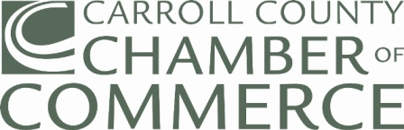 |  |  |  | 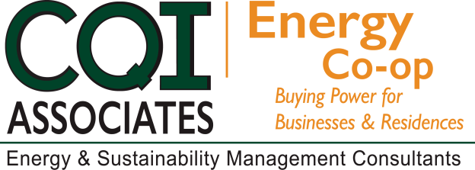
2018 SPRING RENEWAL CAMPAIGN

To: Current Chamber Members with Energy contracts ending thru December 2018

Subject: Chamber Energy Purchasing Cooperative Renewal Program

RENEWAL  We would like to thank you for your continued support for the Energy Purchasing Cooperative Program. The strategic partnership between the Chamber and CQI Associates has resulted in lower energy costs and long-term budget stability for members, since the program’s inception in 2004.  We are ready to commence the Spring campaign for members with contract renewal dates thru December 2018. Your new contract will begin at the end of your current contract.  WEBINAR SCHEDULE  February 13, 2018 - 1:00 p.m.  February 20, 2018 - 11:00 a.m.  February 27, 2018 - 1:00 p.m.  To participate, please select date above (Ctrl + Click) and continue to registration page. |  |  | NO HASSEL PROCESS  - Obtain a Letter of Authorization from  your Chamber website or contact CQI Associates.  - Complete and Sign the Letter of Authorization.  - Provide a recent copy of your Utility bill(s), all pages, for all accounts you are enrolling and a copy of your current contract, if applicable.  Scan and email full copies of all documents to joe@cqiassociates.com or fax to 410-630-5911  Mail the originals to:  Carrol County Chamber of Commerce  9 East Main Street  Westminster, Maryland 21157
The application deadline for the Chamber of
Commerce Energy Purchasing Cooperative
program is Friday, March 2, 2018.
Questions? Please contact:

Joe Tabeling - joe@cqiassociates.com (443)472-3870
Greg Pasha – gregpasha@cqiassociates.com (443)745-8487

"Serving Chamber Members as the Trusted Energy Advisor since 2004"

